**Human rights**

Tuesday, December 15, 2020

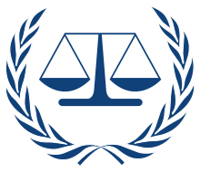

When you and I have some issues with the law and order of a given place, then what is more likely that we do?

1. Stay quiet and sought not to interfere in such matters
2. Or stand up and fight for your rights

If you were me, I would choose to stand up for the rights. Because staying quiet might lead to horrible treatment from others. Similarly, something like this happened when Military dictators and politicians like Adolf Hitler had abused the matter of rights.

People, whom Hitler thought were weak and could never fight for their rights. So, his rule continued and he only wanted the Aryan race to flourish and physically challenged shall die because he thought that they were societal wastes. But we know that physically challenged can also get success by the example of Stephen Hawking, who himself was physically challenged became a great scientist.

Coming to human rights, what are they? Human rights mean rights belonging to every human but there’s more to it. Human rights are rights for every human on the planet regardless of race, sex, nationality, ethnicity, language, religion, or any other status which belongs to any human.

The UN (United Nations) was very confident that equality will be achieved when some rights are given to every individual without discrimination and this came out as human rights. During the time, only the strong men were allowed to live and others all who were weak, physically challenged, women were killed brutally. During the time, people were killed in masses as the concept of human rights wasn’t in existence.

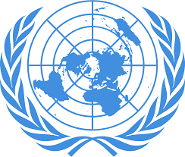

So, what set of rights do they include? to name a few, right to life and liberty, freedom from slavery and torture, freedom of opinion and expression, the right to work and education.

Sometimes, they are often referred to as the Fundamental Rights. They contain around 51 rights

For the correct usage of the rights in all the countries, a law named the international human rights law was established. Its main job is to protect the human rights of others. And as a human, we must protect others’ rights as well as our owns.

So, how do we know about our human rights? We can get to know about these from the universal declaration of rights. It was adopted in a general assembly in Paris on 10th December 1948. For a better understanding of the declaration, the declaration translates to more than 500 languages around the world.

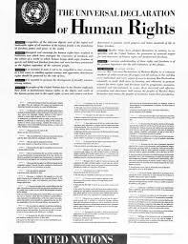

The idea was introduced so that the increased crime rate could be decreased, but one mistake what the UN had done was of making it not compulsory for a nation to obey the given rights.

A nation could agree and disagree with these rights. Countries which mainly have disagreed are Arabian ones, wherein human rights violation continues till this very day.

IF human rights are functional, then why there are a lot of poor in the world, why do people get discriminated. Why women still are not provided equal status in society?

The conditions can only change when we sought to change the world by our terms but respecting the other person.

Hence, human rights are only important when they are followed or it is just a sheet of paper with no moral importance.

Also, to celebrate the importance of human rights, every year on 10th of December Human Rights Day is celebrated.

By

Yash kumar

Class 9